Python Basic Level test

1. Write a code in Python to get the amount alone from the following string:

amt_desc = 'My earnings per month is Rs.250000'

1. Please see the code snippet given below and answer the questions

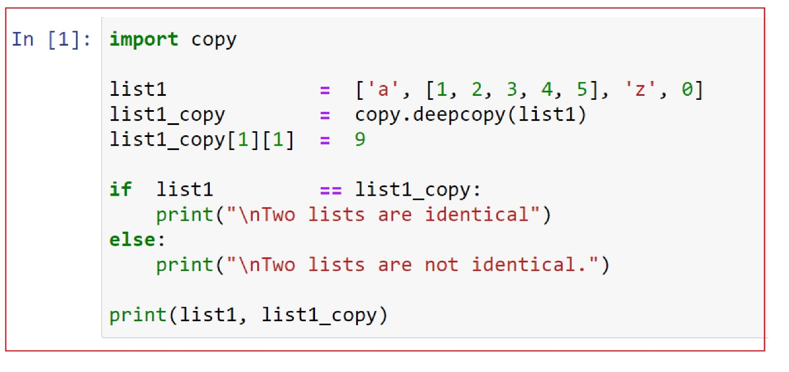

1. Write the output from the above code snippet
2. Please see the code snippet given below and answer the questions:

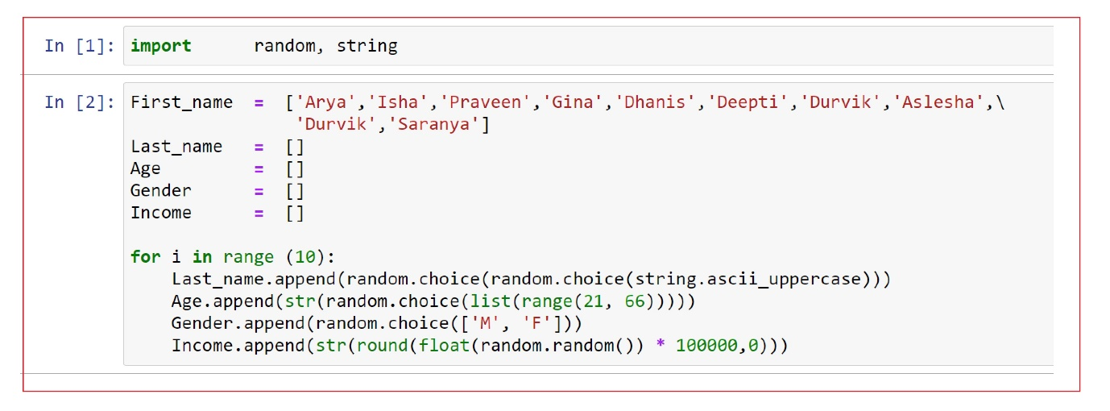

1. Create a dictionary, my_dict in Python using the lists, First_name, Last_name, Age, Gender and Income.
2. How do you get the keys of this dictionary, my_dict?
3. Create a data frame, my_df using the dictionary, my_dict
4. Convert Age and Income to numeric variables
5. Create a csv file from Pandas dataframe, my_df and omit index values
6. Draw boxplot for Income grouped by Gender, a categorical variable using seaborn